

PROBLEM STATEMENT

Day 51 : mt2015_q4a
Day 52 : mt2015_q4b
Day 53 : mt2015_q4
Day 54 : ringer
Day 55 : thermosat
Day 56 : popcount3
Day 57: gatesv
Day 58 : gatesv100
Day 59 : mux2to1
Day 60 :mux2to1v

DAY:51 mt2015_q4a
Problem Statement:
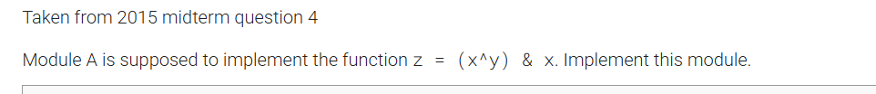
Module Declaration:
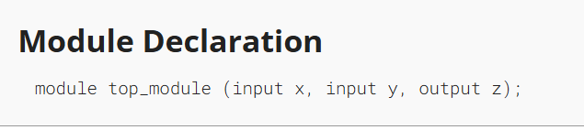
Solution:
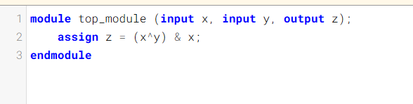

Code:
module top_module (input x, input y, output z);
assign z = (x^y) & x;
endmodule

DAY:52 mt2015_q4b
Problem Statement:
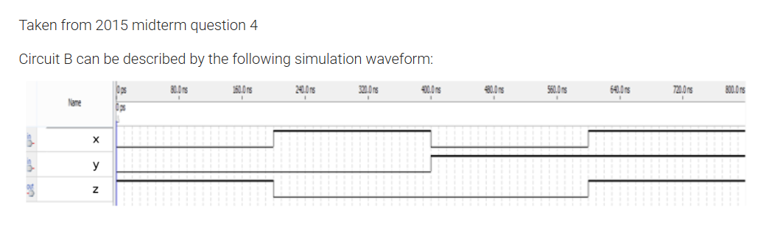
Module Declaration:
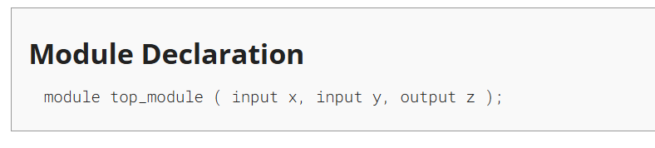
Solution:
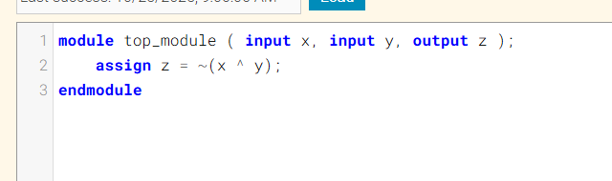
Code:
module top_module ( input x, input y, output z );
assign z = ~(x ^ y);
endmodule
Timing Diagram:
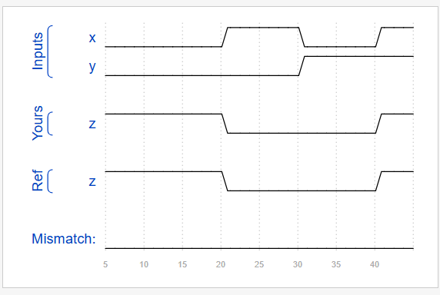
DAY:53 mt2015_q4
Problem Statement:
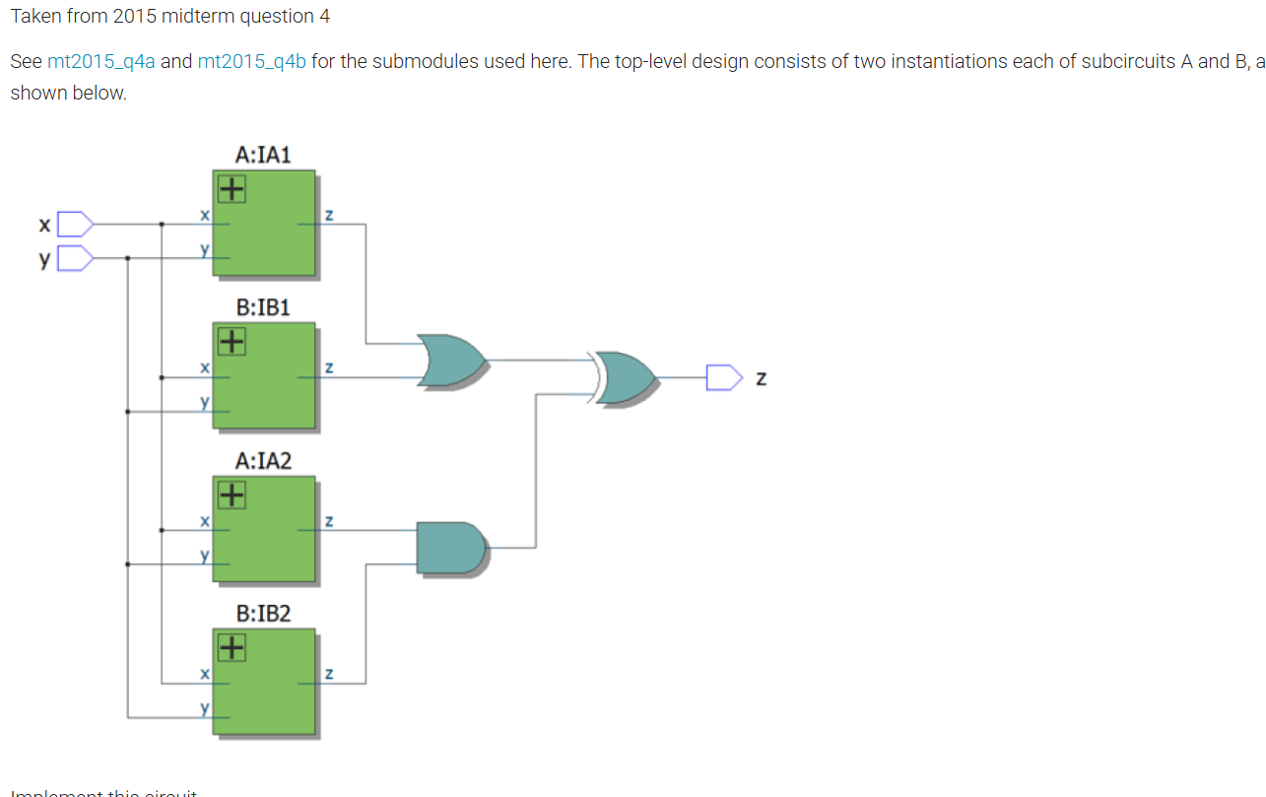

Module Declaration:
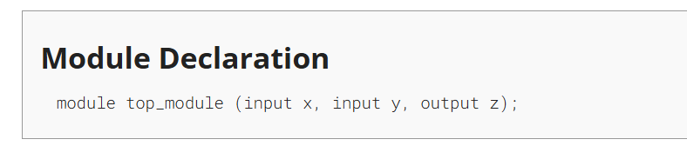
Solution:
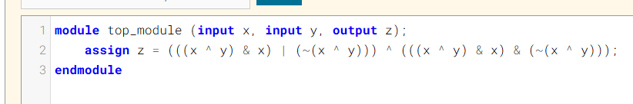
Code:
module top_module (input x, input y, output z);
assign z = (((x ^ y) & x) | (~(x ^ y))) ^ (((x ^ y) & x) & (~(x ^ y)));
endmodule

DAY:54 Ringer
Problem Statement:
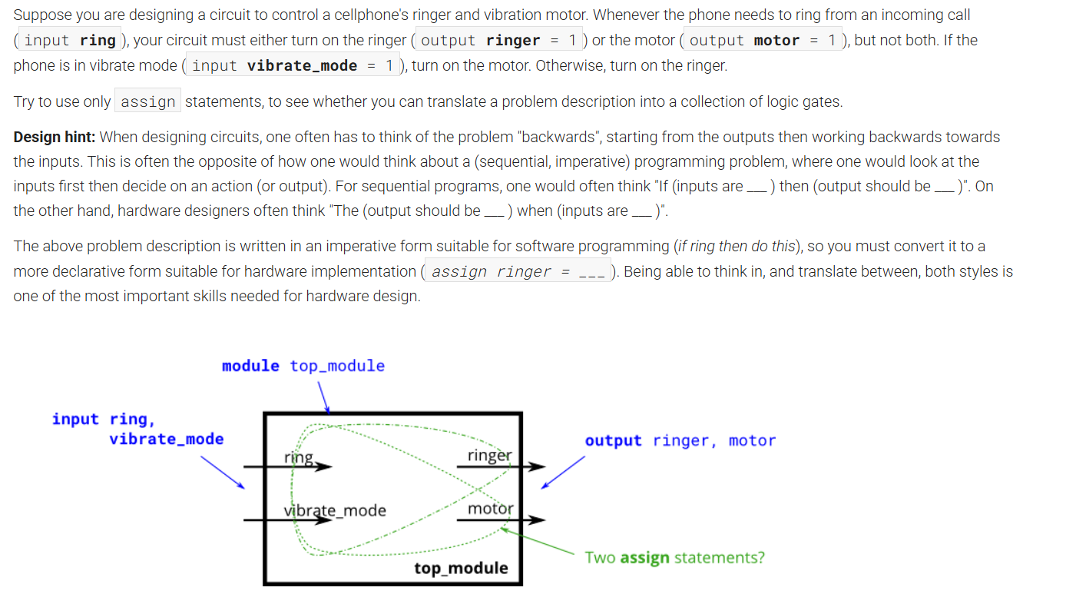
Module Declaration:
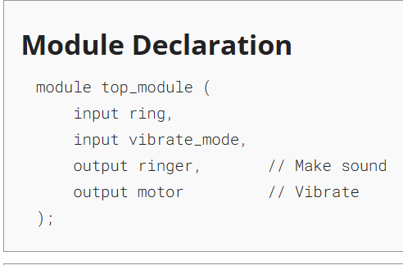

Solution:
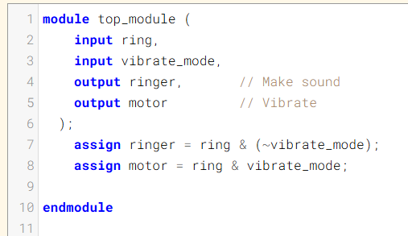
Code:
module top_module (
input ring,
input vibrate_mode,
output ringer, // Make sound
output motor // Vibrate
);
assign ringer = ring & (~vibrate_mode);
assign motor = ring & vibrate_mode;

endmodule

Timing Diagram:
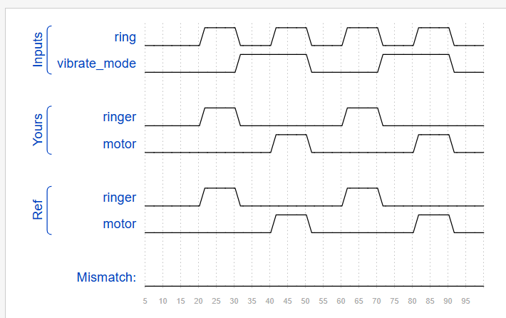

DAY:55 Thermostat
Problem Statement:
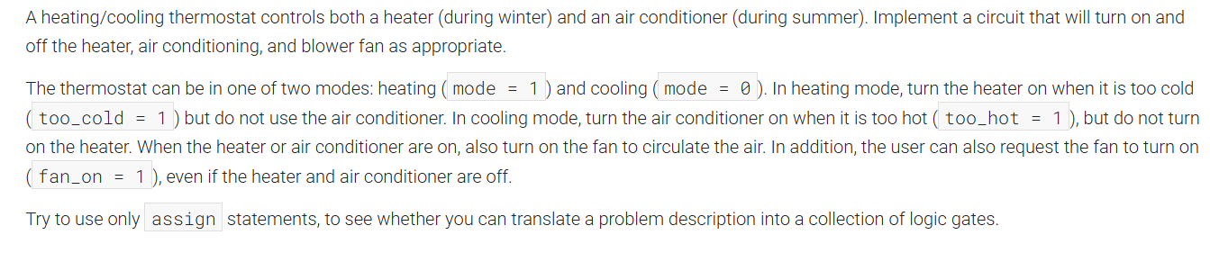

Module Declaration:
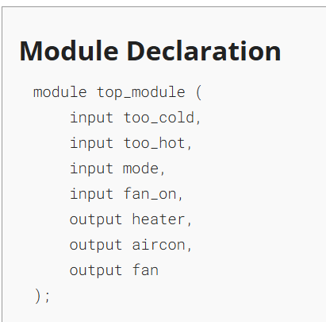
Solution:
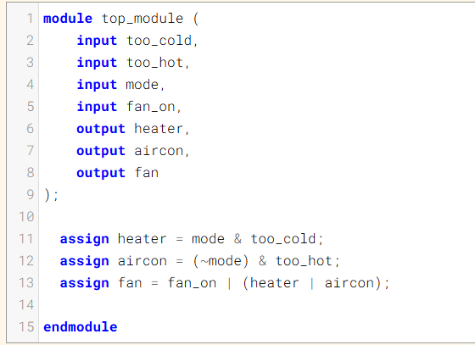
Code:
module top_module (
input too_cold,
input too_hot,
input mode,
input fan_on,
output heater,
output aircon,
output fan
);

assign heater = mode & too_cold;
assign aircon = (~mode) & too_hot;
assign fan = fan_on | (heater | aircon);

endmodule

Timing Diagram:
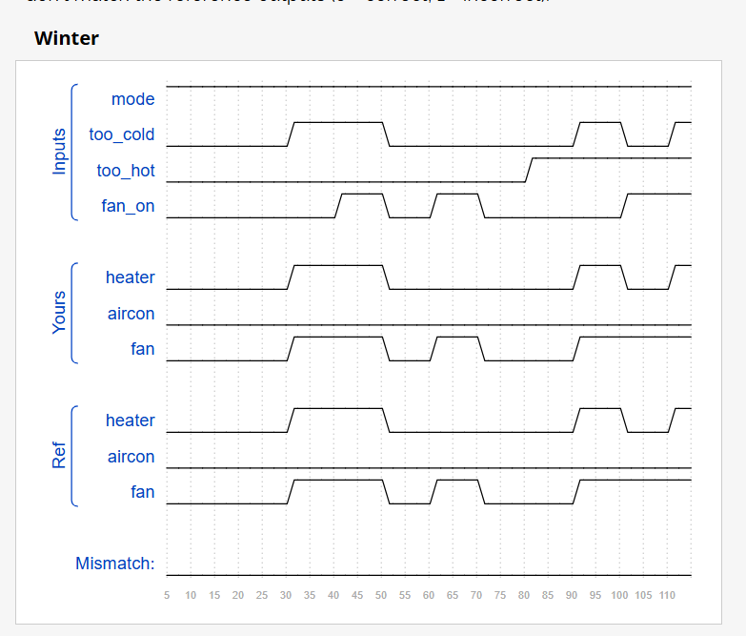
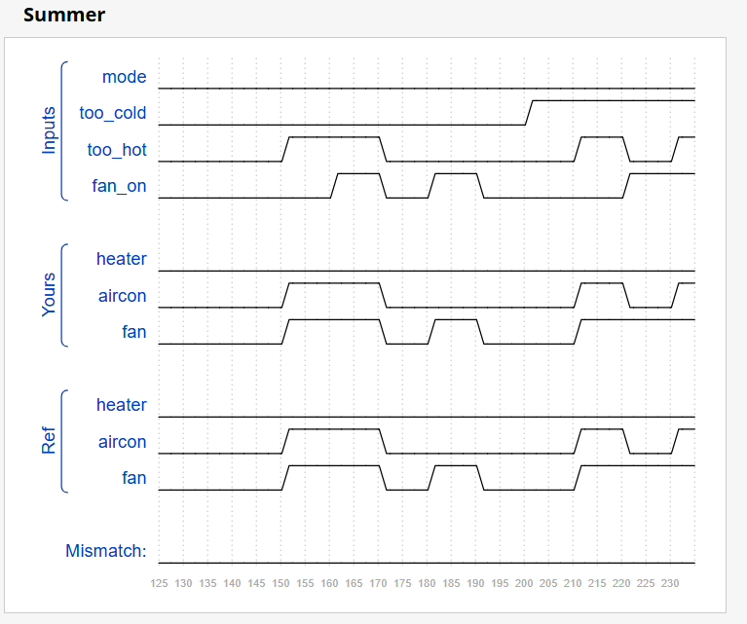

DAY:56 popcount3
Problem Statement:
Module Declaration:
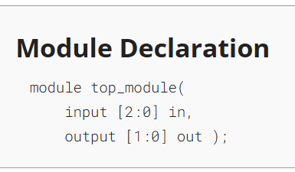
Solution:
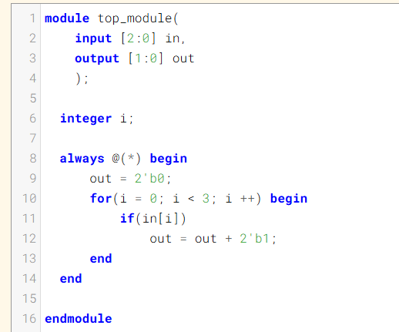

Code:
module top_module(
input [2:0] in,
output [1:0] out
);

integer i;

always @(*) begin
out = 2'b0;
for(i = 0; i < 3; i ++) begin
if(in[i])
out = out + 2'b1;
end
end

endmodule

Timing Diagram:
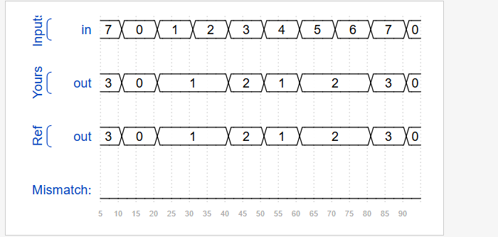
DAY:57 Gatesv
Problem Statement:
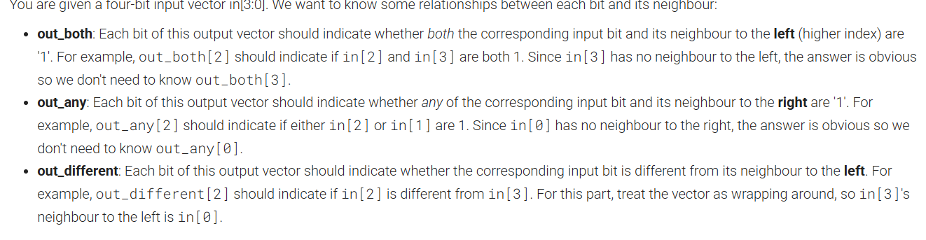
Module Declaration:
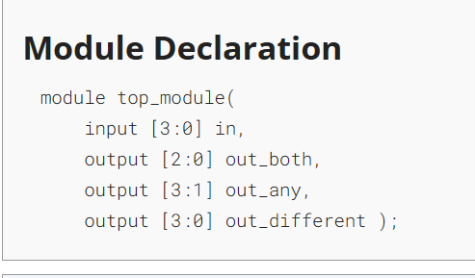
Solution:
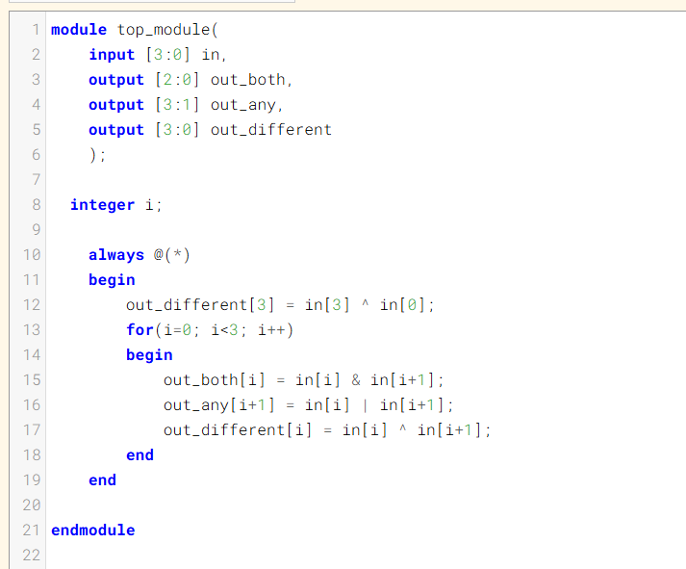
Code:
module top_module(
input [3:0] in,
output [2:0] out_both,
output [3:1] out_any,
output [3:0] out_different
);

integer i;

always @(*)
begin
out_different[3] = in[3] ^ in[0];
for(i=0; i<3; i++)
begin
out_both[i] = in[i] & in[i+1];
out_any[i+1] = in[i] | in[i+1];
out_different[i] = in[i] ^ in[i+1];
end
end

endmodule

Timing Diagram:
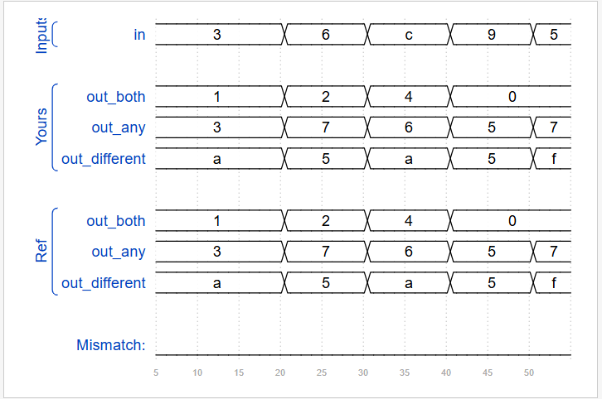

DAY:58 gatesv100
Problem Statement:
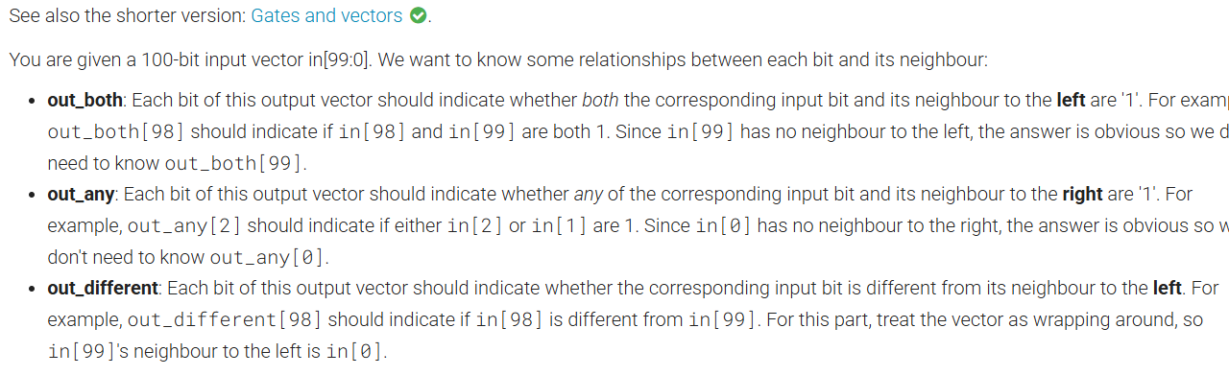

Module Declaration:
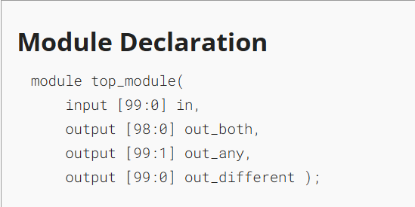
Solution:
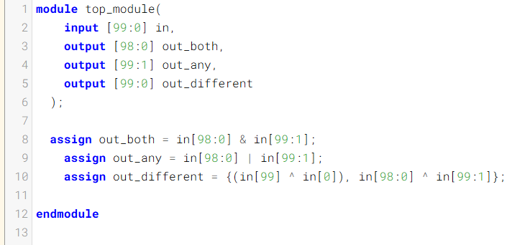

Code:
module top_module(
input [99:0] in,
output [98:0] out_both,
output [99:1] out_any,
output [99:0] out_different
);

assign out_both = in[98:0] & in[99:1];
assign out_any = in[98:0] | in[99:1];
assign out_different = {(in[99] ^ in[0]), in[98:0] ^ in[99:1]};

endmodule
DAY:59 mux2to1
Problem Statement:
Module Declaration:
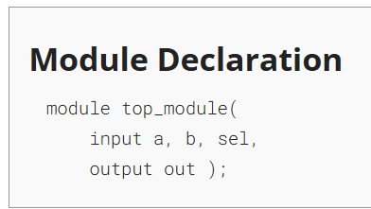

Solution:
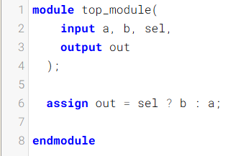
Code:
module top_module(
input a, b, sel,
output out
);
assign out = sel ? b : a;
endmodule
Timing Diagram:
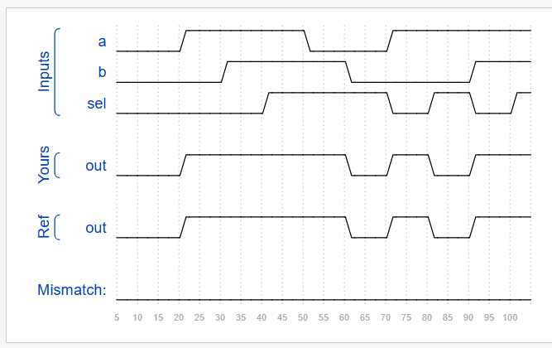

DAY:60 mux2to1v
Problem Statement:
Module Declaration:
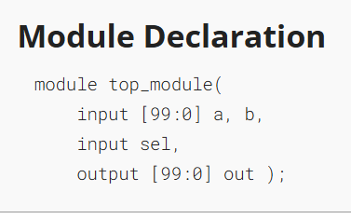
Solution:
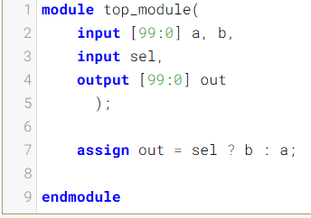

Code:
module top_module(
input [99:0] a, b,
input sel,
output [99:0] out
);

assign out = sel ? b : a;
endmodule
Timing Diagram:
